WANDERER
A Dancing Doll Console Game

Design Documentation & Technical Report
Arshia | Aryan | Manasa

Table of Contents
1. Project Overview
2. Concept & Ideation
3. Design Evolution (Sketches & Iterations)
4. System Architecture
5. Circuit Diagrams & Hardware
6. Software & Code Logic
7. Fabrication & Integration Process
8. Materials & Justification
9. Milestones
10. Challenges & Reflections

1. Project Overview
Wanderer is an interactive arcade-style installation that transforms user input into a playful, performative experience. It brings together physical movement, embedded electronics, and visual feedback to create an engaging character-driven system.

1.1 Project Summary
Wanderer is a two-part interactive system: a player-facing console with push buttons and an OLED mini-game screen, and a stage housing a physically animated doll controlled by servo motors. The player's button inputs travel wirelessly from one ESP32 to another, triggering real doll movements in sync with on-screen prompts.

1.2 Key Project Details
Project Name | Wanderer — A Dancing Doll Console Game

Team Members | Arshia, Aryan & Manasa

Project Type | Interactive Arcade-Style Physical Installation

Core Technology | ESP32 Microcontrollers, ESP-NOW Wireless, Servo Motors, OLED Display

Fabrication Method | Laser-cut stage, Cardboard doll prototype, Breadboard electronics

1.3 Design Goals
- Create a seamless, real-time link between player input and physical doll movement
- Design an engaging rhythm/direction game on an OLED display
- Use wireless (ESP-NOW) communication to keep the stage tidy and cable-free
- Build a visually appealing, arcade-aesthetic installation with laser-cut elements
- Demonstrate the integration of hardware, firmware, and physical fabrication

2. Concept & Ideation

2.1 Inspiration
The core concept behind Wanderer was to bridge the gap between digital game interaction and physical, tangible performance. The team was inspired by classic rhythm arcade games (like Dance Dance Revolution) and marionette/puppet theatre, wanting to combine button-driven gaming with the charm of a physically animated character on stage.

The name 'Wanderer' reflects the character's free-spirited, dance-like movements — she doesn't follow a fixed script but responds to whoever is at the console, making each play session unique.

2.2 Core Concept
The installation has two main interactive layers:
- The OLED Mini-Game: A rhythm-style game where directional arrow cues scroll down the screen and the player must press the matching button at the right moment. This creates a score-and-combo system, making the interaction feel like a game.
- The Physical Stage: A doll suspended on a laser-cut stage, with servo motors at key limb joints. When the player hits the correct input, the doll's arms or legs move — she dances in direct response to the player's actions.

2.3 System Concept Diagram
Player presses button → Console ESP32 reads input → ESP-NOW sends command wirelessly → Stage ESP32 receives command → PCA9685 drives servo motors → Doll limb moves → OLED game updates score/animation

3. Design Evolution — Sketches & Iterations

3.1 Initial Concept Sketches
The earliest design explorations focused on three key questions:
- How should the doll be structured so servo motors can articulate its limbs?
- What should the console look like — handheld, tabletop, or mounted?
- How would the stage be enclosed and themed to match the game's aesthetic?

Initial sketches included a simple humanoid figure with four pivot points (shoulders and hips) connected by strings or rods to servo horns. The team explored both string-pull mechanics and direct-drive servo mounting at the joints, ultimately selecting direct-drive for precision and simplicity
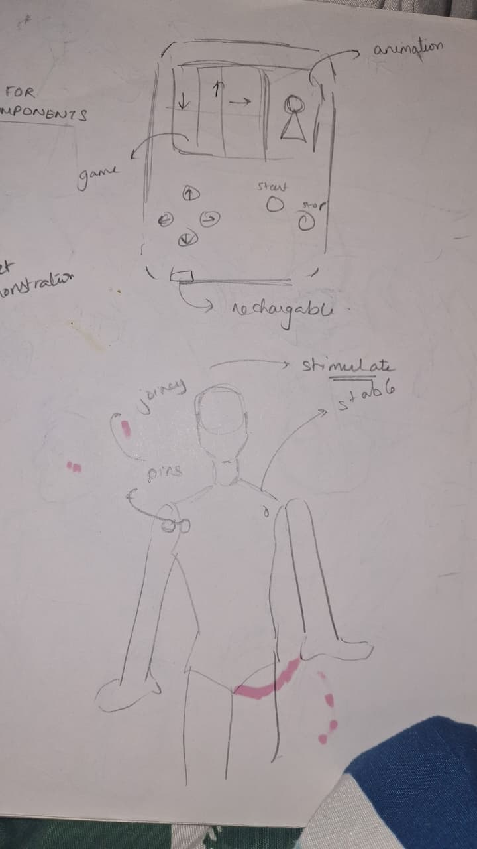
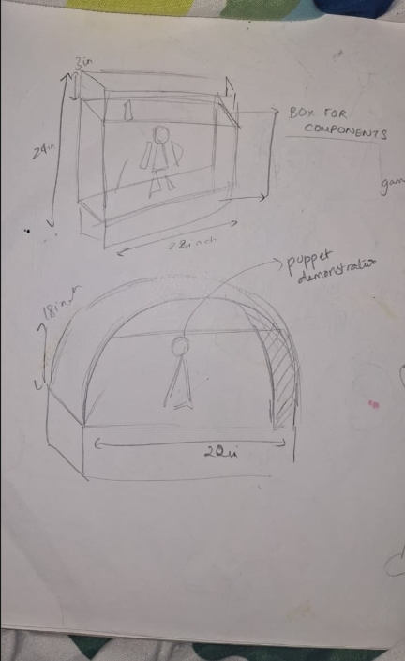

3.2 Iteration 1 — Cardboard Doll Prototype
The first physical iteration was a full-scale doll cut from thick cardboard. This served several purposes:
- Validate the joint pivot positions relative to the doll's proportions
- Test servo horn attachment methods and range of motion
- Identify weight and stiffness requirements for the final material

The cardboard prototype revealed that servo torque was sufficient for lightweight limbs and that the hip joints needed a slightly wider pivot gap to prevent jamming during motion. The arms were also repositioned higher on the torso to give a more natural 'dance' look when raised.

Milestone: First cardboard iteration of the doll — confirmed joint geometry and servo positioning before committing to a final material.

3.3 Iteration 2 — Stage Design
The stage enclosure went through two major design rounds:
- A simple open-frame box (rejected — too exposed, looked unfinished)
- A fully enclosed laser-cut box with a proscenium arch cutout at the front, creating the feel of a miniature theatre stage

The second design was chosen because it:
- Hides the wiring and electronics behind a clean face
- Frames the doll like a performance, which reinforces the 'dancing' theme
- Allows the decorative elements (paper flowers, stars) to be layered onto the arch

Milestone: Getting the entire stage laser cut — the proscenium arch with floral/cloud cutouts was laser-cut from MDF, giving the final installation its distinctive visual identity.

3.4 Iteration 3 — Console Design
The player console evolved from a simple breadboard-and-buttons layout to a more intentional arrangement. The four directional arrow buttons (up, down, left, right) were placed in a diamond/cross pattern familiar from game controllers. Two additional buttons (start/stop) were placed nearby. The OLED display was positioned centrally above the button cluster so players could watch the game while interacting.

4. System Architecture

4.1 High-Level Architecture
Wanderer is a distributed embedded system with two nodes — a Console Node and a Stage Node — communicating wirelessly via ESP-NOW.

CONSOLE NODE (Sender) | STAGE NODE (Receiver)
ESP32 (MicroPython)  4x Arrow Push Buttons  Start / Stop Buttons  1.3" OLED Display (SSD1306)  18650 Li-ion Battery Pack  ESP-NOW Wireless Sender | ESP32 (MicroPython)  PCA9685 PWM Driver  4x Servo Motors  Motor Power Module  Buzzer (optional feedback)  ESP-NOW Wireless Receiver

4.2 Communication Protocol — ESP-NOW
ESP-NOW is a proprietary Espressif peer-to-peer wireless protocol that operates over Wi-Fi hardware without requiring a router or internet connection. It was chosen for this project for several reasons:
- Ultra-low latency: sub-10ms message delivery, critical for real-time doll movement sync
- No router required: the two ESP32s pair directly using MAC address registration
- Low power: more efficient than full Wi-Fi for small, frequent data packets
- Simple API: straightforward send/receive functions in MicroPython's espnow module

The sender ESP32 continuously monitors button states and transmits directional commands ("UP", "DOWN", "LEFT", "RIGHT") as encoded strings. It uses a 'send only if changed' mechanism to prevent flooding the receiver with repeated identical messages when a button is held.

5. Circuit Diagrams & Hardware

5.1 Console Circuit — OLED & Buttons
The console circuit centres around the console ESP32, which handles button reading, OLED rendering, and ESP-NOW transmission simultaneously using a main loop. Below are the key connections:

Component | ESP32 Pin | Notes
OLED SCL (sh1106) | GPIO 18 | I2C Clock
OLED SDA (sh1106) | GPIO 19 | I2C Data
OLED SCL (ssd1306) | GPIO 22 | Second I2C Clock
OLED SDA (ssd1306) | GPIO 23 | Second I2C Data
Right Arrow Button | GPIO 27 | INPUT with PULL_UP
Down Arrow Button | GPIO 14 | INPUT with PULL_UP
Up Arrow Button | GPIO 32 | INPUT with PULL_UP
Left Arrow Button | GPIO 13 | INPUT with PULL_UP
Start Button | GPIO 25 | INPUT with PULL_UP
Stop Button | GPIO 26 | INPUT with PULL_UP

5.2 Stage Circuit — Servo Motors
The stage ESP32 receives commands via ESP-NOW and drives servo motors through a PCA9685 16-channel PWM driver. The PCA9685 communicates with the ESP32 over I2C and generates the PWM signals required by each servo. A dedicated power module provides sufficient current to the servos, as the ESP32's 3.3V output is insufficient for motor loads.

Servo Channel 0 | servo_up — moves the doll's upper body/arms upward

Servo Channel 3 | servo_down — moves lower limbs downward

Servo Channel 6 | servo_left — moves left arm/leg

Servo Channel 4 | servo_right — moves right arm/leg

All servos default to a neutral position (angle 65) on startup via a reset_all() function. This ensures the doll always initialises in a stable, visually neutral pose.

5.3 Power Architecture
The system uses two 18650 Li-ion cells in a battery holder to provide power. The power path is:
- 18650 cells provide raw voltage to a boost/buck converter module
- Regulated 5V output feeds the PCA9685 and servos
- A second regulator provides 3.3V to the ESP32 logic
- The OLED display draws from the 3.3V rail via the ESP32

Why 18650 cells? High energy density, rechargeable, and widely available with reliable discharge curves. Two cells in parallel provide ample current headroom for 4 servos operating simultaneously.

6. Software & Code Logic

6.1 Overview — MicroPython on ESP32
All firmware is written in MicroPython, running on both ESP32 nodes. MicroPython was chosen for its rapid prototyping capability, readable syntax, and strong library support for hardware peripherals (I2C, PWM, GPIO, ESPNOW).

6.2 Code Section 1 — Hardware Initialisation & Configuration
This section sets up all the hardware, configuration, and constants needed for the game to run. It imports modules for GPIO pins, I2C communication, display control, and randomness, along with custom animation frames. It defines pin connections for the OLED displays and multiple buttons with pull-up resistors, and establishes key game parameters.

from machine import Pin, I2C
import time, random, framebuf
import sh1106, ssd1306

# Animation Frames
import idle, up, down, left, right, error

# — CONFIG —
SCL_PIN = 18
SDA_PIN = 19
SSD1306_SCL = 22
SSD1306_SDA = 23

# Directional buttons (active LOW with pull-up)
right_btn = Pin(27, Pin.IN, Pin.PULL_UP)
down_btn = Pin(14, Pin.IN, Pin.PULL_UP)
up_btn = Pin(32, Pin.IN, Pin.PULL_UP)
left_btn = Pin(13, Pin.IN, Pin.PULL_UP)

start_btn = Pin(25, Pin.IN, Pin.PULL_UP)
stop_btn = Pin(26, Pin.IN, Pin.PULL_UP)

LANE_WIDTH = 24
HIT_LINE_Y = 43
GOOD_WINDOW = 250 # ms timing window
DEBOUNCE_MS = 200 # debounce delay

6.3 Code Section 2 — Core Game Logic & State Machine
This section defines how notes are generated, how button presses are handled, and how the game starts and stops. A generate_notes() function creates 50 notes each with a random lane and timestamp. A debounce helper prevents false triggers. The main() function initialises score, combo, error count, and animation state, then enters an infinite loop listening for start/stop events.

def generate_notes():
notes = []
t = 2000
for _ in range(50):
notes.append({
"time": t,
"lane": random.randint(0, 3),
"hit": False,
"passed": False
})
t += 500
return notes

def is_pressed(pin, last_time):
if not pin.value() and time.ticks_diff(now, last_time) > DEBOUNCE_MS:
return True, now
return False, last_time

def main():
score = 0
combo = 0
errors = 0
anim_state = "idle"
running = False
# ... initialise displays, enter main loop
display.text("PRESS START", 10, 25, 1)
display.show()
update_anim("idle")

6.4 Code Section 3 — Main Game Loop
The main game loop continuously updates the OLED display, reads button inputs, and controls animations. It calculates elapsed time, clears the screen, redraws the lane layout with a horizontal hit line, detects new button presses (not held states), updates the animation state, and scrolls notes toward the hit line. Notes within the timing window count as hits; notes that pass the line without input count as errors.

# — GAME LOOP —
now = time.ticks_diff(time.ticks_ms(), start_time)
display.fill(0)

# Draw lane dividers and hit line
for i in range(5):
display.vline(i * LANE_WIDTH, 0, 64, 1)
display.hline(0, HIT_LINE_Y, LANE_WIDTH * 4, 1)

# Detect new button presses
current = [not p.value() for p in pins]
pressed = [False] * 4
for i in range(4):
if current[i] and not last_btn_states[i]:
pressed[i] = True
last_btn_states = current

# Animation reaction
if now - last_hit_time > 1000:
anim_state = "idle"
if pressed[0]: anim_state = "right"; last_hit_time = now
elif pressed[1]: anim_state = "down"; last_hit_time = now
elif pressed[2]: anim_state = "up"; last_hit_time = now
elif pressed[3]: anim_state = "left"; last_hit_time = now

# Score notes
for note in notes:
if note["hit"] or note["passed"]: continue
dist = note["time"] - now
y = int(HIT_LINE_Y - (dist / 30))
lane = note["lane"]
direction = ["right","down","up","left"][lane]
if -10 < y < 64:
x = lane * LANE_WIDTH + (LANE_WIDTH // 2)
draw_arrow(x, y, direction)
if abs(dist) < GOOD_WINDOW:
if pressed[lane]:
note["hit"] = True; combo += 1
elif dist < -GOOD_WINDOW:
note["passed"] = True; errors += 1; anim_state = "error"

6.5 Code Section 4 — ESP-NOW Sender (Console)
This script turns the console ESP32 into an ESP-NOW sender. It initialises Wi-Fi in station mode, registers the receiver's MAC address as a peer, and enters a loop where it checks each directional button. Commands ('UP', 'DOWN', 'LEFT', 'RIGHT') are only transmitted if they differ from the last sent command — this prevents message flooding when a button is held.

import network, espnow
from machine import Pin
import time

peer = b'\xpK\xcan\x8e\xe4' # Receiver MAC address

wifi = network.WLAN(network.STA_IF)
wifi.active(True)
e = espnow.ESPNow()
e.active(True)
e.add_peer(peer)

# Buttons (active LOW)
btn_up = Pin(32, Pin.IN, Pin.PULL_UP)
btn_down = Pin(14, Pin.IN, Pin.PULL_UP)
btn_left = Pin(26, Pin.IN, Pin.PULL_UP)
btn_right = Pin(27, Pin.IN, Pin.PULL_UP)

last_sent = None
while True:
msg = None
if not btn_up.value(): msg = "UP"
elif not btn_down.value(): msg = "DOWN"
elif not btn_left.value(): msg = "LEFT"
elif not btn_right.value():msg = "RIGHT"

if msg and msg != last_sent:
e.send(peer, msg)
last_sent = msg

if btn_up.value() and btn_down.value() and btn_left.value() and btn_right.value():
last_sent = None # Reset when no button pressed

time.sleep(0.05)

6.6 Code Section 5 — ESP-NOW Receiver & Servo Control (Stage)
The stage ESP32 receives ESP-NOW commands and drives the corresponding servo via the PCA9685. A reset_all() function parks all servos at neutral (angle 65) on startup. When a command arrives, the matching servo moves to its active angle, pauses 0.3 seconds, then returns to neutral — creating a crisp, momentary dance movement.

servo_up = Servo(pca, 0)
servo_down = Servo(pca, 3)
servo_left = Servo(pca, 6)
servo_right = Servo(pca, 4)

def reset_all():
servo_up.write(65); servo_down.write(65)
servo_left.write(65); servo_right.write(65)

reset_all()

wifi = network.WLAN(network.STA_IF)
wifi.active(True)
e = espnow.ESPNow()
e.active(True)

print("Receiver Ready")
while True:
host, msg = e.recv()
if msg:
command = msg.decode()
if command == "UP": servo_up.write(100); time.sleep(0.3); servo_up.write(65)
elif command == "DOWN": servo_down.write(30); time.sleep(0.3); servo_down.write(65)
elif command == "LEFT": servo_left.write(100); time.sleep(0.3); servo_left.write(65)
elif command == "RIGHT": servo_right.write(30); time.sleep(0.3); servo_right.write(65)

6.7 Code Section 6 — Limb Motor Movement
An earlier iteration of servo control used direct button monitoring on the stage ESP32 itself. Each button press activates a buzzer beep and increments the target servo angle by 45 degrees — resetting to 0 when it exceeds 180. This creates cyclic, repeating dance motions. Two servos are activated per button press, coordinating opposite limbs for a natural dance look.

def move_servo(ch):
angles[ch] += 45
if angles[ch] > 180: angles[ch] = 0
pulse = angle_to_pulse(angles[ch])
pwm.set_pwm(ch, 0, pulse)

def beep():
buzzer.value(1); time.sleep_ms(100); buzzer.value(0)

while True:
if pressed(btn1):
beep(); move_servo(servo0); move_servo(servo3); time.sleep_ms(250)
if pressed(btn2):
beep(); move_servo(servo4); move_servo(servo6); time.sleep_ms(250)
if pressed(btn3):
beep(); move_servo(servo0); move_servo(servo4); time.sleep_ms(250)

7. Fabrication & Integration Process

7.1 Fabrication Overview
Wanderer's physical construction was broken into three parallel workstreams: the doll, the stage box, and the electronics assembly. These were integrated in the final phase.

7.2 Stage Laser Cutting
The stage enclosure and decorative elements were designed in a vector CAD tool and laser-cut from MDF board. The key features designed for laser cutting were:
- The proscenium arch cutout at the front face — frames the doll and creates a theatrical presentation
- Floral and cloud decorative cutouts — add visual richness and reinforce the game's aesthetic
- Slots and tabs for press-fit assembly — the box panels interlock without glue initially, allowing adjustment
- A rear access panel — for electronics servicing and battery access

The laser cutting process required several test cuts to dial in the correct power/speed settings for clean edges on the 3mm MDF. Too slow caused burning and darkening of the edges; too fast left incomplete cuts. The team ran three test cuts before achieving clean results.

Milestone: Entire stage laser cut — the completed stage with proscenium arch, clouds, and flowers gave the project its final visual identity as a miniature theatre installation.

7.3 Doll Construction
The doll passed through two fabrication stages:
- Cardboard Prototype: Full-scale doll cut freehand from thick corrugated cardboard. Used to validate joint positions, test servo horn attachment, and confirm range of motion. Multiple layers of cardboard were laminated at the torso for rigidity.
- Final Doll: Once geometry was confirmed, the doll was constructed with cleaner materials. Servo horns were hot-glued to the limb joint pivot points. Thin rods or pins served as pivot axles through the torso connection points.

The doll was mounted inside the stage box with the servo motors concealed behind the back panel. Servo signal wires and power leads were routed through slots cut in the back wall to the electronics bay.

7.4 Electronics Assembly & Integration
The integration phase combined all hardware onto a breadboard-based prototype, housed inside the stage box:
- Mount PCA9685 servo driver on breadboard inside stage
- Connect 4 servos to PCA9685 channels 0, 3, 4, 6
- Connect PCA9685 SDA/SCL to Stage ESP32 GPIO 18/19
- Wire power module (18650 cells > boost converter > PCA9685 power rail)
- Mount Stage ESP32, test servo initialisation and reset_all()
- Test ESP-NOW pairing between Console and Stage ESP32s
- Validate end-to-end: button press > wireless command > servo movement

Milestone: Setting up the doll within the box with circuits — the complete electronics stack (ESP32, PCA9685, servos, power module) was integrated inside the stage enclosure, with the doll mounted and all limb servo connections verified.

8. Materials & Justification

8.1 Component List
Component | Qty | Why Chosen
ESP32 Microcontroller | 2x | Dual-core, built-in Wi-Fi hardware for ESP-NOW, abundant GPIO, MicroPython support
PCA9685 PWM Driver | 1x | I2C-controlled 16-channel PWM — offloads servo signal generation from ESP32
SG90 / MG90 Servo Motors | 4x | Lightweight, sufficient torque for cardboard/light limbs, standard PWM interface
1.3" OLED Display (SSD1306) | 1x | High contrast, low power, 128x64 resolution suitable for 4-lane game graphics
1.3" OLED Display (sh1106) | 1x | Second OLED for additional game state display
18650 Li-ion Cells | 2x | High capacity (2600mAh), rechargeable, stable discharge curve for servo loads
Boost/Buck Converter Modules | 2x | Regulate battery voltage to clean 5V (servos) and 3.3V (logic) rails
Push Buttons (tactile) | 6x | Low actuation force, reliable bounce characteristics for gaming input
MDF Board (3mm) | ~ | Laser-cuttable, rigid, holds paint/decoration well, low cost
Cardboard (thick) | ~ | Rapid prototyping of doll geometry before committing to final materials

9. Project Milestones

9.1 Milestone Timeline
# | Milestone | Significance
1 | First cardboard iteration of the doll | Confirmed joint geometry and servo positioning; validated range of motion before committing to final materials.
2 | Connection of all 4 servos through motor driver | Proved that the PCA9685 could drive all four servos simultaneously from a single ESP32 I2C connection, a critical hardware proof-of-concept.
3 | Getting the entire stage laser cut | Transformed the project from a prototype into a polished installation. The proscenium arch and decorative elements defined the final visual identity.
4 | Setting up the doll within the box with circuits | Full hardware integration milestone — all electronics, servos, doll, and enclosure combined into a single working unit for the first time.
5 | ESP-NOW wireless communication working | Console and stage nodes communicated successfully; button press on console triggered servo movement on stage with minimal latency.
6 | OLED game fully functional | The rhythm/direction game ran end-to-end: notes spawned, scrolled, registered hits/misses, tracked score/combo, and displayed animations.

10. Challenges & Reflections

10.1 ESP-NOW Debugging
The wireless communication layer was the most technically challenging aspect of the project. Key difficulties included:
- MAC address pairing: the receiver's MAC address must be hard-coded into the sender. Getting the correct byte sequence required running a network scan script on the receiver first.
- Message flooding: early versions sent a message every loop iteration while a button was held, saturating the receiver. Solved with the 'send only if changed' approach.
- Decoding messages: the received ESP-NOW message arrives as raw bytes; forgetting to call .decode() caused silent failures where the command string never matched the comparison strings.

10.2 Servo Control & Noise
Servo jitter (small unwanted oscillations at rest) was observed when all four servos shared the same power rail as the ESP32 logic. This was resolved by separating the servo power supply onto a dedicated regulator output. The debounce delays in button reading also prevented rapid successive commands that could cause servo stutter.

10.3 OLED Game Timing
The rhythm game required millisecond-precise timing to correctly score note hits. The main loop must complete in under ~5ms to avoid visual judder. Profiling revealed that display.show() was the bottleneck (I2C write of the full framebuffer). The team reduced the game's lane count and simplified note arrow graphics to keep the loop fast enough for smooth gameplay.

10.4 Fabrication Learnings
- Laser cut test pieces first: the first full-size cut used slightly wrong settings and scorched the MDF edges. Always run small test cuts.
- Cardboard prototyping is invaluable: the doll's joint geometry changed significantly between the first sketch and the cardboard prototype. Paper sketches alone do not reveal mechanical constraints.
- Plan wire routing early: cables running from servos to the electronics board were added as an afterthought, creating a messy interior. Future iterations would plan cable channels and clip points from the first CAD design.

10.5 What We Would Do Differently
- Design the enclosure and electronics together from the start, rather than fitting electronics into a pre-built box
- Use a PCB instead of breadboard for the final stage electronics — reduces accidental disconnections
- Add a speaker/buzzer to the stage for audio feedback that complements the doll's movements
- Implement a wireless RSSI check at startup to confirm the ESP-NOW link before the game begins

Wanderer — A Dancing Doll Console Game
Arshia | Aryan | Manasa
Interactive Arcade Installation — Design Documentation

